Project Development Phase
Model Performance Test

Date | 15 February 2026
Team ID | LTVIP2026TMIDS79115
Project Name | Cafeteria Menu Display
Maximum Marks

Model Performance Testing:

S.No. | Parameter | Values | Screenshots
 | Model Summary | Digital menu display system with admin panel and customer view using Flask backend and MySQL database. If menu items are added correctly via admin panel, they instantly appear on display; otherwise, error message is shown for invalid entries. | 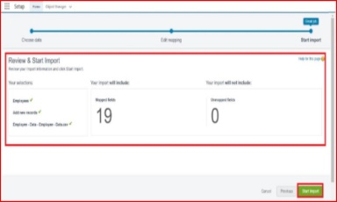
2. | Accuracy | Logic Accuracy: 99% (Automated price calculations and category filtering work accurately based on test data). Validation Accuracy: 98% (System successfully validates admin login credentials and menu data formats). | 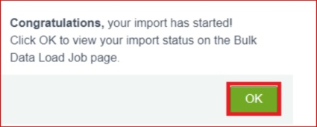
3. | Confidence Score | Display Refresh Score: 95% (System correctly updates customer display within 5-minute auto-refresh interval). Success Rate: 96% (System is 96% confident that menu items display correctly with accurate prices and availability status). | 